Document containing the processed requirements of the client

Radu Andrei Popescu

User Requirement Specifications

Fontys University | Rachelsmolen 1, 5612 MA Eindhoven

2022

Table of Contents

Client Agreements 2

Non-functional requirements 3

NFR-1 3

NFR-2 3

NFR-3 3

Functional requirements 4

Use cases 5

UC-01 - Logging in 5

UC-02a – Place Order 6

UC-02b – Edit Order 6

UC-03a – Adding a new product 7

UC-03b – Edit product data 8

UC-03c – Mark product as unavailable 9

UC-04a – Edit an employee 10

UC-05a – Add item to Favourite list 11

UC-05b – Remove item from Favourite list 11

UC-06a – Add new Category 12

UC-06b – Edit Category 12

UC-07a – Add new Sub-Category 13

UC-07b – Edit Sub-Category 13

Screen prints and webpage 14

# Client Agreements

Through my client meetings with Mrs. Chua Jessie, we have agreed to adhere to the following:

* Meetings will occur every Tuesday at 9.00 early in the morning
* Any change to the project should be discussed in any of those meetings
* The requirements for this application should be FR-05 (Advertisement) and FR-09 (Favourite List)

# Non-functional requirements

### NFR-1

Maintainable and extendable  
Proper OO principles must be applied to ensure good maintainability and extensibility of the   
code base.

### NFR-2

Bug free system   
Appropriate testing techniques must be used when implementing the system to ensure   
proper functioning and delivering of a bug free application

### NFR-3

Secure software   
Only authorized people may make use of the system and can only access data they are   
authorized for. Passwords and user input must also be handled appropriately.

# Functional requirements

Any new requirements that could be implemented should the timeslot allows, must be discussed with the client prior to implementation.

|  |  |  |  |  |
| --- | --- | --- | --- | --- |
| Importance | Category | ID | Title | Description |
| Must |  | FR-1 | Manage the catalogue with items (groceries and goods) | Employees at the back office must be able to manage the items  of the company’s catalogue. |
| Must |  | FR-2 | Support of placing order process | When a customer is interested in buying items online, they can visit the website of the company and place an order. |
| Must |  | FR-5 | Advertisement | Based on certain market analysis, employees at the back office must be able to put advertisement for selected items. An employee needs first select popular items, specify discount (bonus), the discount week (start and end dates), and then put them on an advertisement page. |
| Must |  | FR-9 | Favourite list of items | Customers can select items and add them into the favourite list. |

## Use cases

### UC-01 - Logging in

Actor – Employee

#### Main Success Scenario

1) Actor enters correct email and password in the login page

2) System registers the information

3) Actor triggers action of logging in

4) System verifies if the credentials are correct and proceeds to show logged-in-user content.

#### Extensions

1a) Actor enters an incorrect email not matching the password which will be entered in step 1.

.1 system displays invalid information message.  
.2 return to MSS step 1.

1b) Actor enters an incorrect password not matching the email which will be entered in step 1.

.1 system displays invalid information message.  
.2 return to MSS step 2.

### UC-02a – Place Order

Actor – Customer

Pre-condition: Actor needs to be logged in on the website

#### Main Success Scenario

1) Actor chooses an item from a list of products filtered by categories

2) System adds to shopping cart chosen item

4) Actor goes to his shopping cart and proceeds to checkout

5) System verifies data from shopping cart

6) Actor adds billing address and shipping information

7) System verifies shipping information and billing address and places the order for the employees

#### Extensions

1a) Actor skips step 1) and goes directly to step 4)

.1 system displays message saying “Cart is empty”.  
 .2 return to MSS step 1.

6a) Actor enters invalid shipping information

.1 system displays invalid information message

.2 return to MSS step 6)

### UC-02b – Edit Order

Actor – Customer

Pre-condition: Actor already has some items in the shopping cart

#### Main Success Scenario

1. Actor triggers action of removing item from Shopping Cart
2. System removes the item from the shopping cart
3. System verifies data from the shopping cart

### UC-03a – Adding a new product

Actor – Employee

Pre-condition: Actor is logged in as Product Manager

#### Main Success Scenario

1. Actor fills in product name, category, subcategory, price, unit, image on the Product Management page
2. System registers the information provided
3. Actor triggers action adding the product
4. System verifies if the data is correct and stores the product information if so

#### Extensions

1a) Actor does not enter a product information

.1 system display missing information message.  
 .2 return to MSS step 1.

1b) Actor enters invalid information

.1 system display invalid information message

.2 return to MSS step 1.

### UC-03b – Edit product data

Actor – Employee

Pre-condition: Actor is logged in as Product Manager

#### Main Success Scenario

1. Actor indicates the product they want to edit from a list of products on the Product Management page
2. System selects the indicated product and fills form with its information
3. Actor edits desired information about the product
4. System verifies if the data is correct and stores the product information if so

#### Extensions

3a) Actor does not enter product data

.1 system display missing information message.  
 .2 return to MSS step 1.

1a) Actor does not choose a product before entering data

.1 system display “Select a product first” message.  
 .2 return to MSS step 1.

### UC-03c – Mark product as unavailable

Actor – Employee

Pre-condition: Actor is logged in Product Manager

#### Main Success Scenario

1. Actor indicates the product they want to edit from a list of products on the Product Management page
2. System registers the selection
3. Actor marks the product as unavailable
4. System updates the product status

#### Extensions

1a) Actor does not choose a product  
 .1 display invalid information message.

.2 return to MSS step 1.

Should the marked product be in customers order it will still be delivered to those customers but new customers will not be able to buy it.

### UC-04a – Edit an employee

Actor – Employee

Pre-condition: Actor is logged in as Human Resources

#### Main Success Scenario

1. Actor indicates an employee from a list of employees from the Human Resources page
2. System registers selection and fills the form with employee data
3. Actor edits the information (email, name) about the employee
4. System verifies if the credentials are correct and stores the information if so

#### Extensions

1a) Actor does not enter any information.  
 .1 system display invalid information message  
 .2 continue to MSS step 2.

2a) Actor enters an email that is already used

.1 system display email already used message

.2 continue to MSS step 2.

2a) Actor does not choose an employee before entering data

.1 system display “Select an employee first” message.  
 .2 return to MSS step 1.

### UC-05a – Add item to Favourite list

Actor – Customer

Pre-condition: Actor is logged in on website

#### Main Success Scenario

1. Actor triggers action of adding a product to their favourites
2. System proceeds to adding the product data as a favourite

#### Extensions

1a) Item already exists in the favourite list.  
 .1 display message “Already in the favourites”.  
 .2 return to MSS step 1.

2a) Actor is not logged in

.1 display message Not logged in  
 .2 return to MSS step 1.

### UC-05b – Remove item from Favourite list

Actor – Customer

Pre-condition: Actor is logged in on website

#### Main Success Scenario

1) Actor triggers action of removing from Favourites a product in the Favourites web page

2) System verifies the information and add them to the database.

#### Extensions

1a) Actor is not logged in

.1 display message Not logged in  
 .2 return to MSS step 1.

### UC-06a – Add new Category

Actor – Employee

Pre-condition: Actor is logged in as Product Manager

#### Main Success Scenario

1. Actor fills in a new Category name from the Category manager page
2. System registers information
3. Actor triggers action of creating a new category
4. System verifies if data already exists and stores it if not

#### Extensions

4a) Category already exists.  
 .1 system display message “Category already exists”.  
 .2 return to MSS step 1.

1a) Actor does not fill in any information

.1 system display message invalid information

.2 return to MSS step 1.

### UC-06b – Edit Category

Actor – Employee

Pre-condition: Actor is logged in as Product Manager

#### Main Success Scenario

1. Actor indicates what category to edit from the Category manager page
2. System fills the form with category information
3. Actor edits the category information
4. System verifies the information and add them to the database.

#### Extensions

3a) Actor does not add information

.1 system display invalid information message  
 .2 continue to MSS step 3.

1a) Actor does not indicate a category

.1 system display please select a category first message  
 .2 continue to MSS step 3.

### UC-07a – Add new Sub-Category

Actor – Employee

Pre-condition: Actor is logged in as Product Manager

#### Main Success Scenario

1. Actor indicates a category to add a subcategory from the Category manager page
2. System registers selection
3. Actor fills in a new sub-category name
4. System registers information
5. Actor triggers action of creating a new sub-category
6. System verifies information and adds to the database

#### Extensions

6a) Sub-category already exists.  
 .1 display message “Sub-Category already exists”.  
 .2 return to MSS step 1.

1a) Actor does not select a category.  
 .1 display message “Please select a category first”.  
 .2 return to MSS step 1.

### UC-07b – Edit Sub-Category

Actor – Employee

Pre-condition: Actor is logged in as Product Manager

#### Main Success Scenario

1. Actor indicates a category to change a subcategory from the Category manager page
2. System registers selection
3. Actor indicates a sub-category to change
4. System registers information
5. Actor edits information about sub-category
6. System registers information
7. Actor triggers action of editing sub-category
8. System verifies information and adds to the database

#### Extensions

1a) Actor does not add information

.1 system display invalid information message  
 .2 continue to MSS step 3.

2a) Actor does not select a category.  
 .1 system display message “Please select a category first”.  
 .2 return to MSS step 1.

2a) Actor does not select a sub-category.  
 .1 system display message “Please select a sub-category first”.  
 .2 return to MSS step 1.

### Screen prints and webpage

#### Landing page

This page is the landing page. It will be the first this the customer sees when entering the website. From here he can quickly go to see all the products, filter them by category or visit his favourite items. You can also see discounts and offers here.

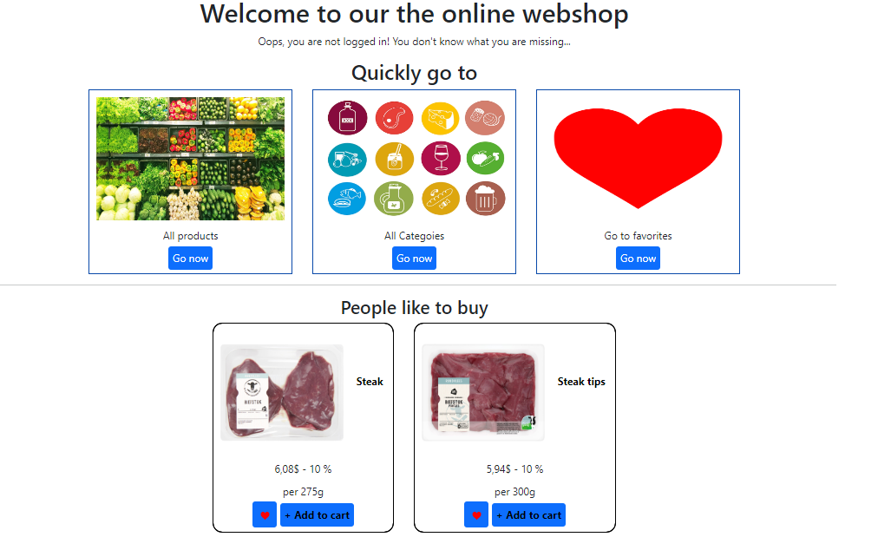

#### Categories and sub-categories

From the landing page, the catalogue can be filtered by categories and sub-categories. Each category has one or multiple sub-categories, however the sub-categories do not have sub-categories themselves.

Categories: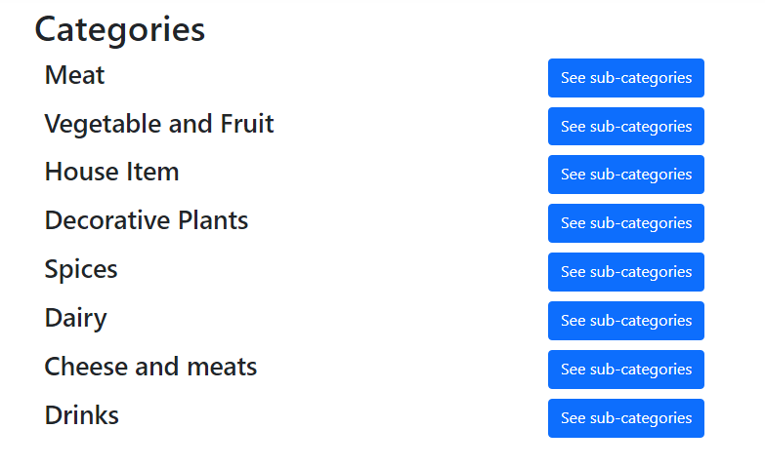

Sub-Categories of MEAT:

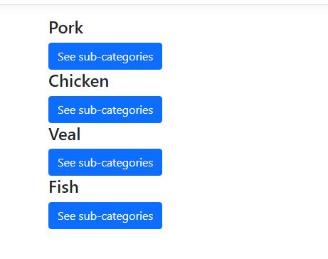

#### Cart

On this page the actor can view his shoppping cart.

The price of the item placed in the cart is calculated by the quantity of it times the price of it.

The actor can also remove products from the car

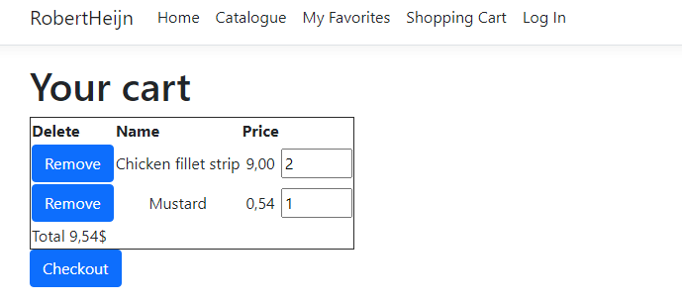

#### Favourites

On this page the actor can view his favorites and remove them if they see fit (UC-5b).

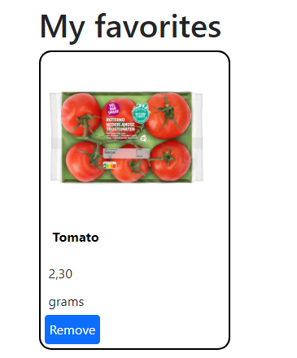

If actor is not logged in, this is displayed.

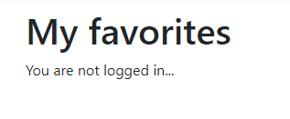

#### Product Management

In the product management the employee can add a new product, edit an existing one or view all products.

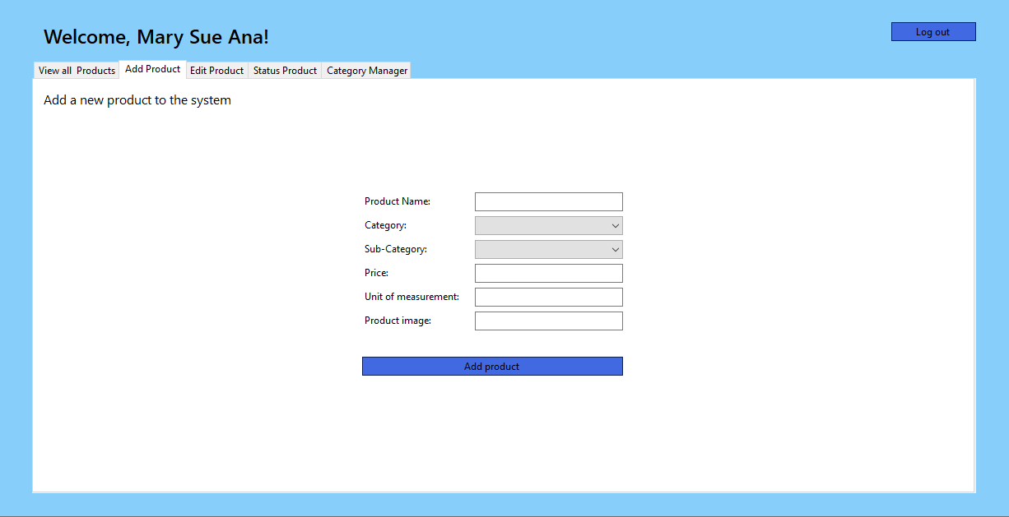

#### Category Management

In the category management the employee can manage the data of both the categories and sub-categories (UC-6 and UC-7).

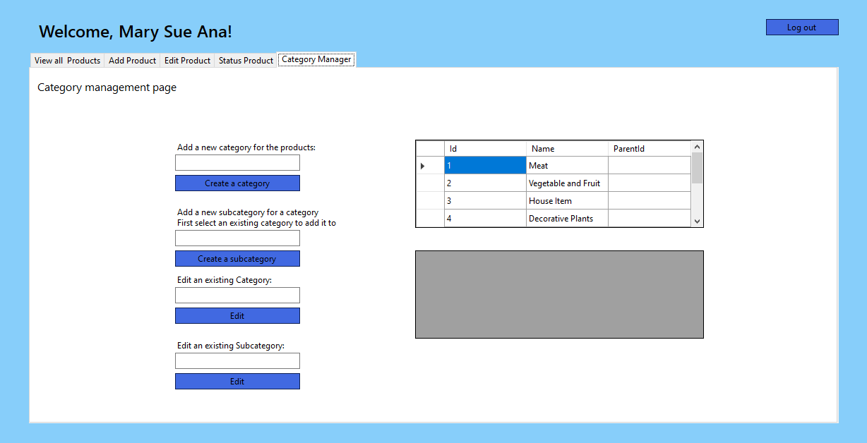

After the Actor selects a category and then a sub-category

